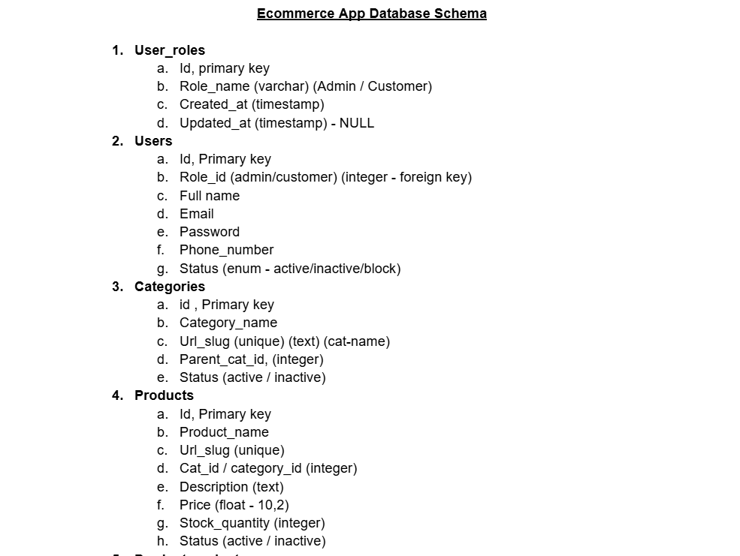
CREATE TABLE user_roles (
id INT PRIMARY KEY AUTO_INCREMENT,
role_name VARCHAR(50) NOT NULL, -- Admin / Customer
created_at TIMESTAMP DEFAULT CURRENT_TIMESTAMP,
updated_at TIMESTAMP NULL DEFAULT NULL
);
2>
CREATE TABLE users (
id INT PRIMARY KEY AUTO_INCREMENT,
role_id INT,
full_name VARCHAR(100) NOT NULL,
email VARCHAR(100) UNIQUE NOT NULL,
password VARCHAR(255) NOT NULL,
phone_number VARCHAR(15),
status ENUM('active', 'inactive', 'block') DEFAULT 'active',

FOREIGN KEY (role_id) REFERENCES user_roles(id)
);

3>
CREATE TABLE categories (
id INT PRIMARY KEY AUTO_INCREMENT,
category_name VARCHAR(100) NOT NULL,
url_slug VARCHAR(150) UNIQUE,
parent_cat_id INT,
status ENUM('active', 'inactive') DEFAULT 'active',

FOREIGN KEY (parent_cat_id) REFERENCES categories(id)
);
4>
CREATE TABLE products (
id INT PRIMARY KEY AUTO_INCREMENT,
product_name VARCHAR(150) NOT NULL,
url_slug VARCHAR(150) UNIQUE,
category_id INT,
description TEXT,
price DECIMAL(10,2),
stock_quantity INT,
status ENUM('active', 'inactive') DEFAULT 'active',

FOREIGN KEY (category_id) REFERENCES categories(id)
);
Improvements (Very Important for Your Project 🚀)
Since you are building a real project (you mentioned MERN/backend earlier), consider adding:
🔹 Add timestamps everywhere
created_at TIMESTAMP DEFAULT CURRENT_TIMESTAMP,
updated_at TIMESTAMP DEFAULT CURRENT_TIMESTAMP ON UPDATE CURRENT_TIMESTAMP
🔹 Password security
- NEVER store plain passwords
- Use hashing (bcrypt in backend)
🔹 Indexing
CREATE INDEX idx_email ON users(email);
CREATE INDEX idx_category ON products(category_id);

🔥 What’s Missing (Next Tables You Should Add)
To make it a complete ecommerce system, you should also create:
- orders
- order_items
- cart
- payments
- reviews
- addresses
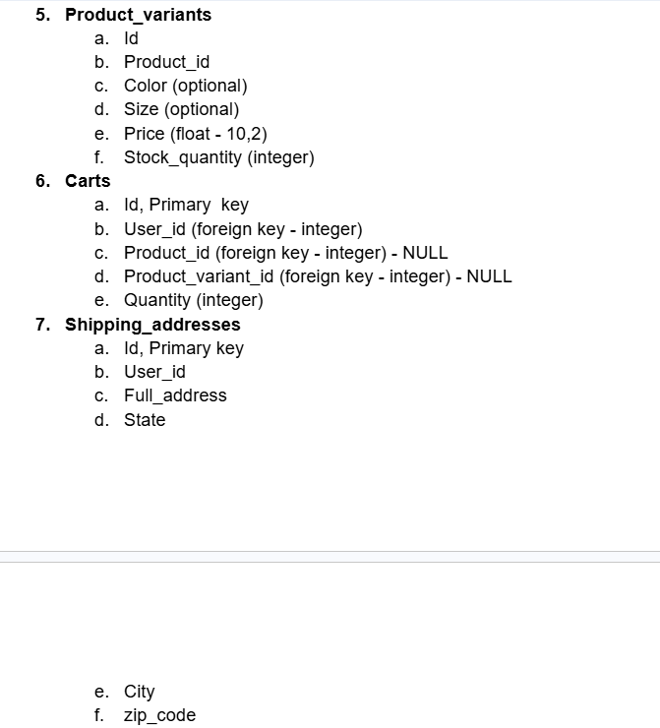
5>
CREATE TABLE product_variants (
id INT PRIMARY KEY AUTO_INCREMENT,
product_id INT NOT NULL,
color VARCHAR(50),
size VARCHAR(50),
price DECIMAL(10,2),
stock_quantity INT,

FOREIGN KEY (product_id) REFERENCES products(id)
);

6>
CREATE TABLE carts (
id INT PRIMARY KEY AUTO_INCREMENT,
user_id INT NOT NULL,
product_id INT NULL,
product_variant_id INT NULL,
quantity INT DEFAULT 1,

FOREIGN KEY (user_id) REFERENCES users(id),
FOREIGN KEY (product_id) REFERENCES products(id),
FOREIGN KEY (product_variant_id) REFERENCES product_variants(id)
);

7>
CREATE TABLE shipping_addresses (
id INT PRIMARY KEY AUTO_INCREMENT,
user_id INT NOT NULL,
full_address TEXT NOT NULL,
state VARCHAR(100),
city VARCHAR(100),
zip_code VARCHAR(10),

FOREIGN KEY (user_id) REFERENCES users(id)
);

Important Improvements (Must for Real Projects)
⚠️ 1. Prevent invalid cart data
Right now, both product_id and product_variant_id can be NULL or filled together ❌
👉 Better approach:
CHECK (
(product_id IS NOT NULL AND product_variant_id IS NULL)
OR
(product_id IS NULL AND product_variant_id IS NOT NULL)
);

⚠️ 2. Add timestamps everywhere
created_at TIMESTAMP DEFAULT CURRENT_TIMESTAMP,
updated_at TIMESTAMP DEFAULT CURRENT_TIMESTAMP ON UPDATE CURRENT_TIMESTAMP

⚠️ 3. Improve variants logic (VERY IMPORTANT)
Instead of putting price in both:
- products
- product_variants
👉 Choose ONE:
- If variants exist → price should be in product_variants
- If no variants → keep price in products

⚠️ 4. Normalize cart (Best Practice 🚀)
Better structure:
- carts → one per user
- cart_items → multiple products
If you want, I can redesign this cleanly.

🧠 Final Structure Summary
Now your DB supports:
✔ Users & roles
✔ Categories & products
✔ Product variants (size/color)
✔ Cart system
✔ Shipping addresses

🚀 What Next?
To make it complete ecommerce backend, next step:
- ✅ orders + order_items (MOST IMPORTANT)
- ✅ payments
- ✅ wishlist
- ✅ reviews & ratings

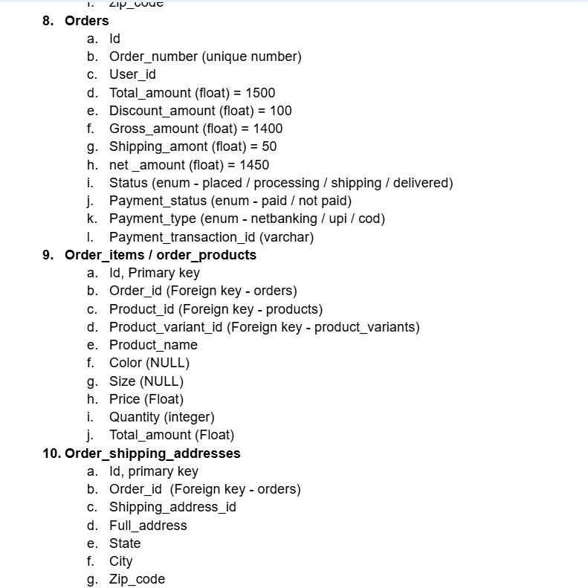
8>
CREATE TABLE orders (
id INT PRIMARY KEY AUTO_INCREMENT,
order_number VARCHAR(50) UNIQUE NOT NULL,
user_id INT NOT NULL,

total_amount DECIMAL(10,2),
discount_amount DECIMAL(10,2) DEFAULT 0,
gross_amount DECIMAL(10,2),
shipping_amount DECIMAL(10,2) DEFAULT 0,
net_amount DECIMAL(10,2),

status ENUM('placed', 'processing', 'shipping', 'delivered') DEFAULT 'placed',
payment_status ENUM('pending', 'paid', 'failed') DEFAULT 'pending',
payment_type ENUM('netbanking', 'upi', 'cod'),

payment_transaction_id VARCHAR(100),

created_at TIMESTAMP DEFAULT CURRENT_TIMESTAMP,

FOREIGN KEY (user_id) REFERENCES users(id)
);

9>
CREATE TABLE order_items (
id INT PRIMARY KEY AUTO_INCREMENT,
order_id INT NOT NULL,
product_id INT,
product_variant_id INT,

product_name VARCHAR(150),
color VARCHAR(50),
size VARCHAR(50),

price DECIMAL(10,2),
quantity INT,
total_amount DECIMAL(10,2),

FOREIGN KEY (order_id) REFERENCES orders(id),
FOREIGN KEY (product_id) REFERENCES products(id),
FOREIGN KEY (product_variant_id) REFERENCES product_variants(id)
);

10>
CREATE TABLE order_shipping_addresses (
id INT PRIMARY KEY AUTO_INCREMENT,
order_id INT NOT NULL,
shipping_address_id INT,

full_address TEXT,
state VARCHAR(100),
city VARCHAR(100),
zip_code VARCHAR(10),

FOREIGN KEY (order_id) REFERENCES orders(id),
FOREIGN KEY (shipping_address_id) REFERENCES shipping_addresses(id)
);

VERY IMPORTANT DESIGN FIXES (Don’t Skip This)
⚠️ 1. Why duplicate data in order_items?
You stored:
- product_name
- color
- size
- price
👉 This is CORRECT ✅ (Best Practice)
Because:
If product changes later, old order should NOT change.

⚠️ 2. Amount Calculation Logic
Your fields:
- total_amount = 1500
- discount = 100
- gross = 1400
- shipping = 50
- net = 1450
👉 Formula:
gross_amount = total_amount - discount_amount
net_amount = gross_amount + shipping_amount

⚠️ 3. Add constraint for items
CHECK (
(product_id IS NOT NULL AND product_variant_id IS NULL)
OR
(product_id IS NULL AND product_variant_id IS NOT NULL)
);

⚠️ 4. Add indexing (Performance 🚀)
CREATE INDEX idx_orders_user ON orders(user_id);
CREATE INDEX idx_order_items_order ON order_items(order_id);

🧠 FINAL ARCHITECTURE (Now You Have 🔥)
Your ecommerce DB now supports:
✅ Users & roles
✅ Categories & products
✅ Variants (size/color)
✅ Cart system
✅ Orders system
✅ Payment tracking
✅ Shipping system
👉 This is industry-level schema (good for MCA project + interviews 💯)

🚀 What Next (Very Powerful Step)
Now I recommend:
🔥 Option 1:
👉 Full Backend APIs (Node.js + Express + MySQL)
🔥 Option 2:
👉 Convert into MERN (MongoDB schema)
🔥 Option 3:
👉 Build Admin Panel + User Flow

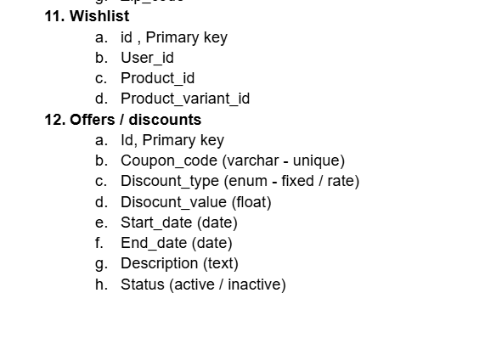

11>
CREATE TABLE wishlist (
id INT PRIMARY KEY AUTO_INCREMENT,
user_id INT NOT NULL,
product_id INT NULL,
product_variant_id INT NULL,

created_at TIMESTAMP DEFAULT CURRENT_TIMESTAMP,
updated_at TIMESTAMP DEFAULT CURRENT_TIMESTAMP ON UPDATE CURRENT_TIMESTAMP,

FOREIGN KEY (user_id) REFERENCES users(id) ON DELETE CASCADE,
FOREIGN KEY (product_id) REFERENCES products(id) ON DELETE CASCADE,
FOREIGN KEY (product_variant_id) REFERENCES product_variants(id) ON DELETE CASCADE,

-- Ensure only one of product_id OR product_variant_id is used
CHECK (
(product_id IS NOT NULL AND product_variant_id IS NULL)
OR
(product_id IS NULL AND product_variant_id IS NOT NULL)
),

-- Prevent duplicate wishlist entries
UNIQUE (user_id, product_id, product_variant_id)
);

12>

CREATE TABLE offers (
id INT PRIMARY KEY AUTO_INCREMENT,

coupon_code VARCHAR(50) UNIQUE NOT NULL,
discount_type ENUM('fixed', 'rate') NOT NULL,
discount_value DECIMAL(10,2) NOT NULL,

min_order_value DECIMAL(10,2) DEFAULT 0,
max_discount_amount DECIMAL(10,2) DEFAULT NULL,

usage_limit INT DEFAULT NULL, -- total usage limit
used_count INT DEFAULT 0, -- how many times used

per_user_limit INT DEFAULT 1, -- per user usage limit

start_date DATETIME NOT NULL,
end_date DATETIME NOT NULL,

description TEXT,
status ENUM('active', 'inactive') DEFAULT 'active',

created_at TIMESTAMP DEFAULT CURRENT_TIMESTAMP,
updated_at TIMESTAMP DEFAULT CURRENT_TIMESTAMP ON UPDATE CURRENT_TIMESTAMP,

-- Ensure valid discount values
CHECK (
(discount_type = 'fixed' AND discount_value > 0)
OR
(discount_type = 'rate' AND discount_value BETWEEN 1 AND 100)
),

-- Ensure valid dates
CHECK (end_date > start_date)
);

